A

Mini Project Report

On

**“BGIS”**

Submitted to

**CHHATTISGARH SWAMI VIVEKANAND TECHNICAL UNIVERSITY BHILAI**

in partial fulfillment of the requirement of for the award of degree

Of

**Bachelors of Technology**

In

**COMPUTER SCIENCE AND ENGINEERING**

**By**

**Harshit Kumar Sinha**

**DEPARTMENT OF COMPUTER SCIENCE AND ENGINEERING**



**SHRI SHANKARACHARYA TECHNICAL CAMPU,**

**JUNWANI, BHILAI(C.G.)**

**SESSION 2021-2022**

# CERTIFICATE

This is to certify that the thesis report of the project submitted is an outcome of the project entitled **“BGIS”** carried out by **Harshit Kumar Sinha** bearing **Roll no. 301402220053** carried out under my guidance and supervision for the award of Degree in B.Tech in **Computer Science and Engineering** of Chhattisgarh Swami Vivekanand Technical university, Bhilai(C.G.),India.

To the best of my knowledge the report.

(1)Embodies the work of the candidates herself/himself.

(2)Fulfills the requirements of the ordinance relating to the B.Tech Degree of the University.And ,

(3)Is up to the desired standard for the purpose of which is submitted.

(Signature of the Subject Teacher)

Mrs. Snehlata Mandal

Professor

Computer Science & Egineering Department

**Shri ShankaraCharya Technical Campus**

**Junwani,Bhilai(C.G.)**

The project work as mentioned above is hereby being recommended and forwarded for examination and evaluation.

**(Signature of Head of Department with seal)**

**ACKNOWLEDGEMENT**

**I would like to express my special thanks of gratitude to my teacher Mrs.Snehlata Mandal who gave me the golden opportunity to do this wonderful project on the Mini Project, which also helped me in doing a lot of Research and i came to know about so many new things I am really thankful to them.**

**While I was making this project , a lot of information that I found helped me in programming and I am glad that I was able to complete this project and was able to understand many things.**

**I am making this project not only for marks but to also increase my knowledge.**

(Signature of student)

## Abstract

Battlegrounds Mobile India (in short form BGMI,previously known as PUBG Mobile India is an online multiplayer battle royale game developed and published by Krafton.The game is exclusively for the Indian users. The game released on 2 July 2021 for Android devices, and on 18 August 2021 for iOS devices.

## INTRODUCTION

### ABOUT YOUR PROJECT

Battlegrounds Mobile India BGMI

Mode- Multiplayer

On 2 September 2020, the Ministry of Electronics and Information Technology, Government of India banned PUBG Mobile along with 117 Chinese applications stating that the apps were engaged in activities which were prejudicial and threat to sovereignty and integrity of India, defence of India, security of the state and public order under Section 69A of the Information Technology Act.

In November 2020, it was reported that PUBG Mobile was going to be relaunched in India, named as PUBG Mobile India.On 24 November 2020, a news published on The Times of India reported that PUBG Corporation (renamed PUBG Studios) and South Korea’s video game company Krafton Inc. have registered PUBG India Private Limited under Ministry of Corporate Affairs, Government of India to relaunch PUBG Mobile in India.

In May 2021, it was reported that PUBG Mobile was being rebranded as Battlegrounds Mobile India to enter in the Indian gaming market.After that on 7 May 2021, a news by The Indian Express reported that, Krafton confirmed in a press statement that they were going to launch Battlegrounds Mobile India, a similar game to PUBG Mobile.

### Definition of an BGIS:

### Players who have registered for iQ00 BATTLEGROUND MOBILE INDIA SERIES 2021 will have to play 15 matches with their registered team members over the given time period. The top 10 of 15 matches will be considered for evalution and scored accordingly. In case of a tie, certain parameters such as finishes, survival times, accuracy, etc will be considered. Top 1024 teams will qualify for the next round. Note: Only the first 15 matches played with registered team members shall be deemed valid.

team members shall be deemed valid.

### The Aim of an BGIS Website:-

This website is generally for updation about eSports more and more. From this website you can get to know about each and every eSports which are famous or underrated in the world(for very eSports there is a updation required in the website).

## Tools and Technology used

### BOOTSTRAP:-

**Bootstrap is maintained by a** [**small team of developers**](https://github.com/orgs/twbs/people) **on GitHub. We’re actively looking to grow this team and would love to hear from you if you’re excited about CSS at scale, writing and maintaining vanilla JavaScript plugins, and improving build tooling processes for frontend code.**

### VISUAL STUDIO CODE:-

**Visual Studio Code** is a [source-code editor](https://en.wikipedia.org/wiki/Source-code_editor) made by [Microsoft](https://en.wikipedia.org/wiki/Microsoft) for [Windows](https://en.wikipedia.org/wiki/Windows), [Linux](https://en.wikipedia.org/wiki/Linux) and [macOS.](https://en.wikipedia.org/wiki/MacOS)[9] Features include support for [debugging](https://en.wikipedia.org/wiki/Debugging), [syntax highlighting](https://en.wikipedia.org/wiki/Syntax_highlighting), [intelligent code](https://en.wikipedia.org/wiki/Intelligent_code_completion)

[completion,](https://en.wikipedia.org/wiki/Intelligent_code_completion) [snippets,](https://en.wikipedia.org/wiki/Snippet_(programming)) [code refactoring](https://en.wikipedia.org/wiki/Code_refactoring), and embedded [Git](https://en.wikipedia.org/wiki/Git). Users can change the [theme](https://en.wikipedia.org/wiki/Theme_(computing)),

[keyboard shortcuts,](https://en.wikipedia.org/wiki/Keyboard_shortcut) preferences, and install [extensions](https://en.wikipedia.org/wiki/Plug-in_(computing)) that add additional functionality.

Visual Studio Code was first announced on April 29, 2015, by Microsoft at the 2015 [Build](https://en.wikipedia.org/wiki/Build_(developer_conference)) conference. A [preview](https://en.wikipedia.org/wiki/Technical_preview) build was released shortly thereafter.

On November 18, 2015, the source of Visual Studio Code was released under the [MIT License,](https://en.wikipedia.org/wiki/MIT_License) and made available on [GitHub](https://en.wikipedia.org/wiki/GitHub). Extension support was also announced. On April 14, 2016, Visual Studio Code graduated from the [public preview](https://en.wikipedia.org/wiki/Beta_software) stage and was [released to the Web.](https://en.wikipedia.org/wiki/Software_release_life_cycle#Web_release) Microsoft has released most of Visual Studio Code's [source code](https://en.wikipedia.org/wiki/Source_code) on [GitHub](https://en.wikipedia.org/wiki/GitHub) under the permissive [MIT License,](https://en.wikipedia.org/wiki/MIT_License) while the releases by Microsoft are proprietary [freeware.](https://en.wikipedia.org/wiki/Freeware)

In the [Stack Overflow](https://en.wikipedia.org/wiki/Stack_Overflow) 2021 Developer Survey, Visual Studio Code was ranked the most popular developer environment tool, with 70% of 82,000 respondents reporting that they use it.

### HTML:-

The **HyperText Markup Language**, or **HTML** is the standard [markup language](https://en.wikipedia.org/wiki/Markup_language) for documents designed to be displayed in a [web browser.](https://en.wikipedia.org/wiki/Web_browser) It can be assisted by technologies such as [Cascading Style Sheets](https://en.wikipedia.org/wiki/Cascading_Style_Sheets) (CSS) and [scripting languages](https://en.wikipedia.org/wiki/Scripting_language) such as [JavaScript.](https://en.wikipedia.org/wiki/JavaScript)

[Web browsers](https://en.wikipedia.org/wiki/Web_browser) receive HTML documents from a [web server](https://en.wikipedia.org/wiki/Web_server) or from local storage and [render](https://en.wikipedia.org/wiki/Browser_engine) the documents into multimedia web pages. HTML describes the structure of a [web page](https://en.wikipedia.org/wiki/Web_page) [semantically](https://en.wikipedia.org/wiki/Semantic_Web) and originally included cues for the appearance of the document.

[HTML elements](https://en.wikipedia.org/wiki/HTML_element) are the building blocks of HTML pages. With HTML constructs, [images](https://en.wikipedia.org/wiki/HTML_element#Images_and_objects) and other objects such as [interactive forms](https://en.wikipedia.org/wiki/Fieldset) may be embedded into the rendered page. HTML provides a means

to create [structured documents](https://en.wikipedia.org/wiki/Structured_document) by denoting structural [semantics](https://en.wikipedia.org/wiki/Semantics) for text such as headings, paragraphs, lists, [links](https://en.wikipedia.org/wiki/Hyperlink), quotes and other items. HTML elements are delineated by *tags*, written using [angle brackets.](https://en.wikipedia.org/wiki/Bracket#Angle_brackets) Tags such as <**img** /> and <**input** /> directly introduce content into the page. Other tags such as <**p**> surround and provide information about document text and may include other tags as sub-elements. Browsers do not display the HTML tags, but use them to interpret the content of the page.

HTML can embed programs written in a [scripting language](https://en.wikipedia.org/wiki/Scripting_language) such as [JavaScript](https://en.wikipedia.org/wiki/JavaScript), which affects the behavior and content of web pages. Inclusion of CSS defines the look and layout of content. The [World Wide Web Consortium](https://en.wikipedia.org/wiki/World_Wide_Web_Consortium) (W3C), former maintainer of the HTML and current maintainer of the CSS standards, has encouraged the use of CSS over explicit presentational HTML since 1997.A form of HTML, known as [HTML5](https://en.wikipedia.org/wiki/HTML5), is used to display video and audio, primarily using the <**canvas**> element, in collaboration with javascript.

### CSS:-

**Cascading Style Sheets** (**CSS**) is a [style sheet language](https://en.wikipedia.org/wiki/Style_sheet_language) used for describing the [presentation](https://en.wikipedia.org/wiki/Presentation_semantics) of a document written in a [markup language](https://en.wikipedia.org/wiki/Markup_language) such as [HTML.](https://en.wikipedia.org/wiki/HTML)CSS is a cornerstone technology of the [World Wide Web,](https://en.wikipedia.org/wiki/World_Wide_Web) alongside HTML and [JavaScript](https://en.wikipedia.org/wiki/JavaScript).

CSS is designed to enable the separation of presentation and content, including [layout,](https://en.wikipedia.org/wiki/Page_layout) [colors](https://en.wikipedia.org/wiki/Color), and [fonts](https://en.wikipedia.org/wiki/Typeface). This separation can improve content [accessibility](https://en.wikipedia.org/wiki/Accessibility); provide more flexibility and control in the specification of presentation characteristics; enable multiple [web pages](https://en.wikipedia.org/wiki/Web_page) to share formatting by specifying the relevant CSS in a separate .css file, which reduces complexity and repetition in the structural content; and enable the .css file to be [cached](https://en.wikipedia.org/wiki/Cache_(computing)) to improve the page load speed between the pages that share the file and its formatting.

Separation of formatting and content also makes it feasible to present the same markup page in different styles for different rendering methods, such as on-screen, in print, by voice (via speechbased browser or [screen reader)](https://en.wikipedia.org/wiki/Screen_reader), and on [Braille-based](https://en.wikipedia.org/wiki/Braille_display) tactile devices. CSS also has rules for alternate formatting if the content is accessed on a [mobile device](https://en.wikipedia.org/wiki/Mobile_device).

The name *cascading* comes from the specified priority scheme to determine which style rule applies if more than one rule matches a particular element. This cascading priority scheme is predictable.

## Working With Project

**Sample CSS Code:-**

*{

padding: 0px;

margin: 0%;

box-sizing: border-box;

}

.about {

position: relative;

width: 100%;

display: flex;

}

.about .contentBx {

background: rgb(4, 75, 75);

padding: 75px;

width: 50%;

}

.heading {

font-size: 33px;

font-weight: 600;

letter-spacing: 1px;

color: rgb(255, 255, 255);

margin-bottom: 20px;

font-family: "Times New Roman", Times, serif;

font-weight: 100;

letter-spacing: 2px;

}

.drop{

color: red;

}

.text {

font-size: 16px;

font-weight: 300;

letter-spacing: 1px;

}

.about .imgBx{

background-size: cover;

width: 50%;

max-height:fit-content;

background-position: center;

}

.about .imgBx img{

width: 100%;

}

.titleText{

color: white;

}

.titleText span {

color: yellow;

font-weight: 700;

font-size: 1.8em;

}

.footer

{

background: #162c3b;

padding: 20px 100px;

display: flex;

justify-content: space-between;

align-items: center;

}

**SNAPSHOT WITH EXPLANATION:-**

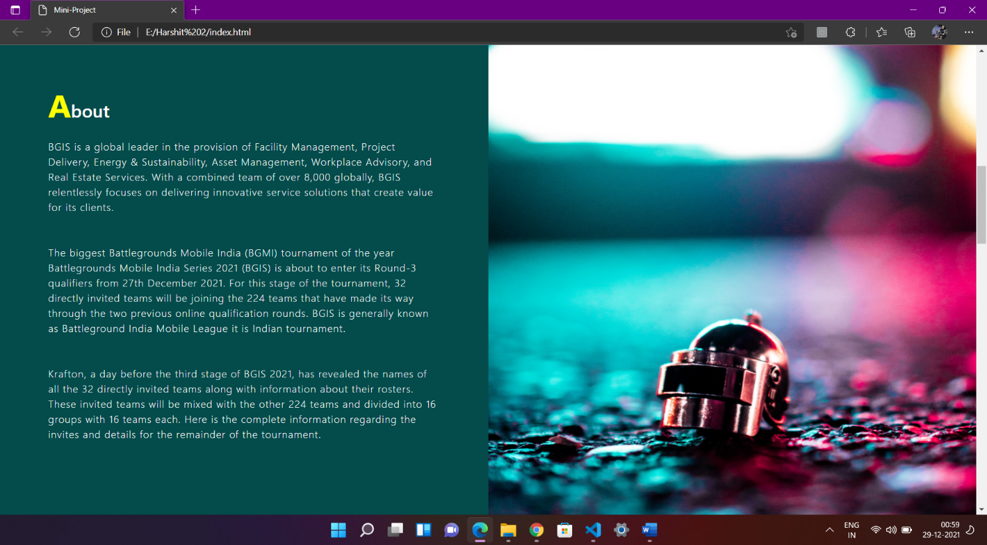

**Image 1**

**ABOVE IMAGE:-**

This is our main page where we can add various data we want to show our about page.

Above example is the first page of my website which I made about eSports BGIS. that information.

**BELOW IMAGE:-**

In below image (IMAGE 2) we can see that how we created various esports bgis page by using Html, Css, Javascript and bootstrap.

## IMAGE 2

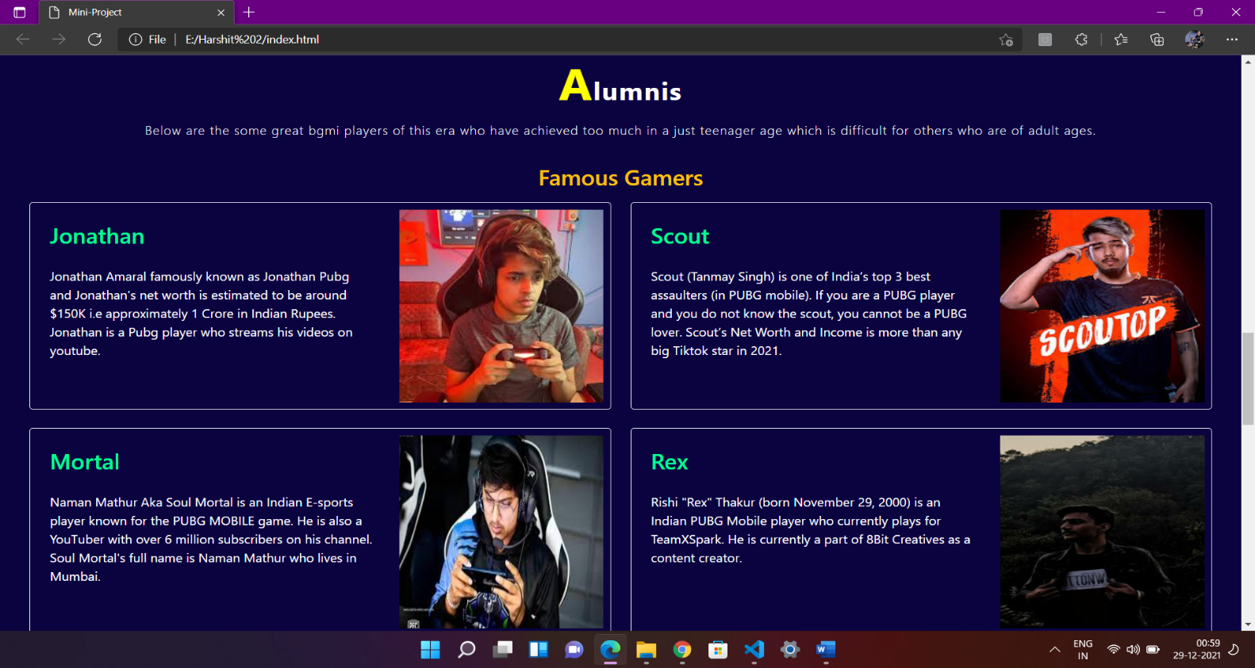

**CONCLUSION AND SCOPE FOR FUTURE WORK**

# Conclusion:-

This website is a collection of knowledge about eSports(BGIS). It will have description of various more BGMI tournament lately when I work more on it. It is just a wikipedia of the topic eSports(BGIS).

# Future Works:-

The work done in project can be extended along several interesting directions, among these are:

1. This project can be hosted after updating more on it.
2. This project can be the website which shows support in eSports(BGIS).